CS 5404 Assignment 5

Wei Luo

In my matlab code, I use the H computed in HW4 first, but in this report, I use the advice H (from Dr. Yin’s email) to run my code. Just run “HW5.m”, it will show you the results.

1. **In the forward warping, use the nearest neighbor for interpolation;**

The detail is in function “ForwardWarping.m”. And the result is below:

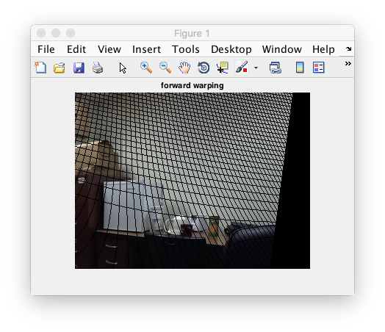

1. **In the backward warping, use the nearest neighbor for interpolation;**

The detail is in function “BackwardWarping1.m” and “BackwardWarping2.m”. The results are below:

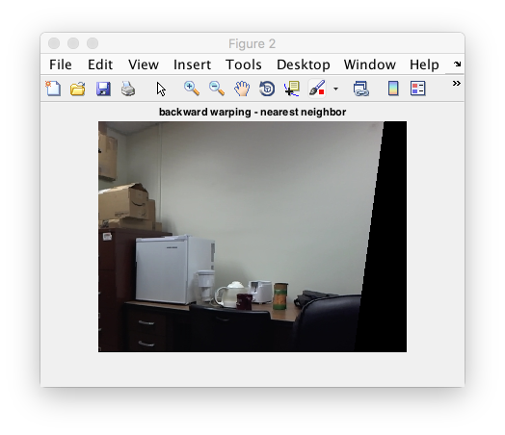

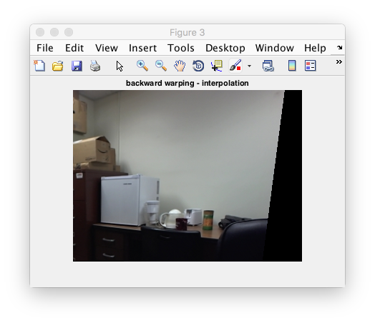

1. **Try Matlab’s interp2() function.**

The detail function is in “BackwardWarping_Interp2.m”. And the result is below:

